**Instructions to fill the Excel file for Bulk UDIN Update**

1. Login to e-Filing Portal and then select the **e-File** menu

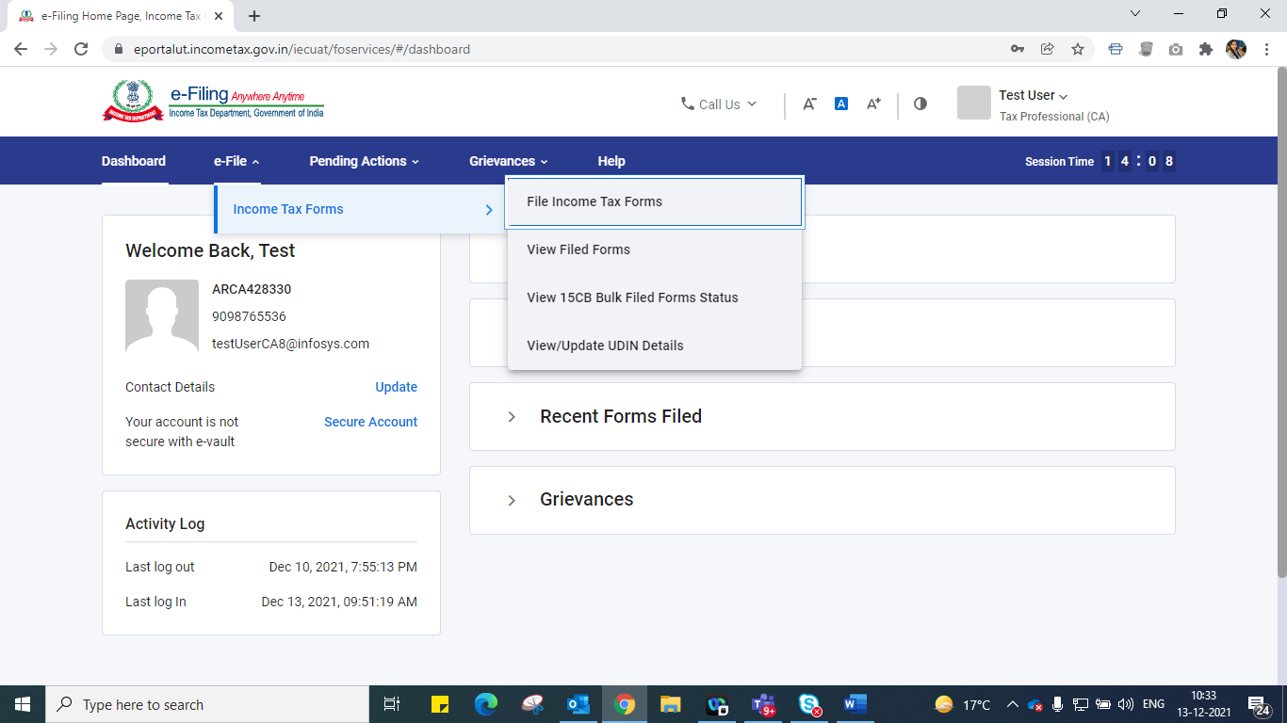

1. Click on **View/Update UDIN Details** menu option

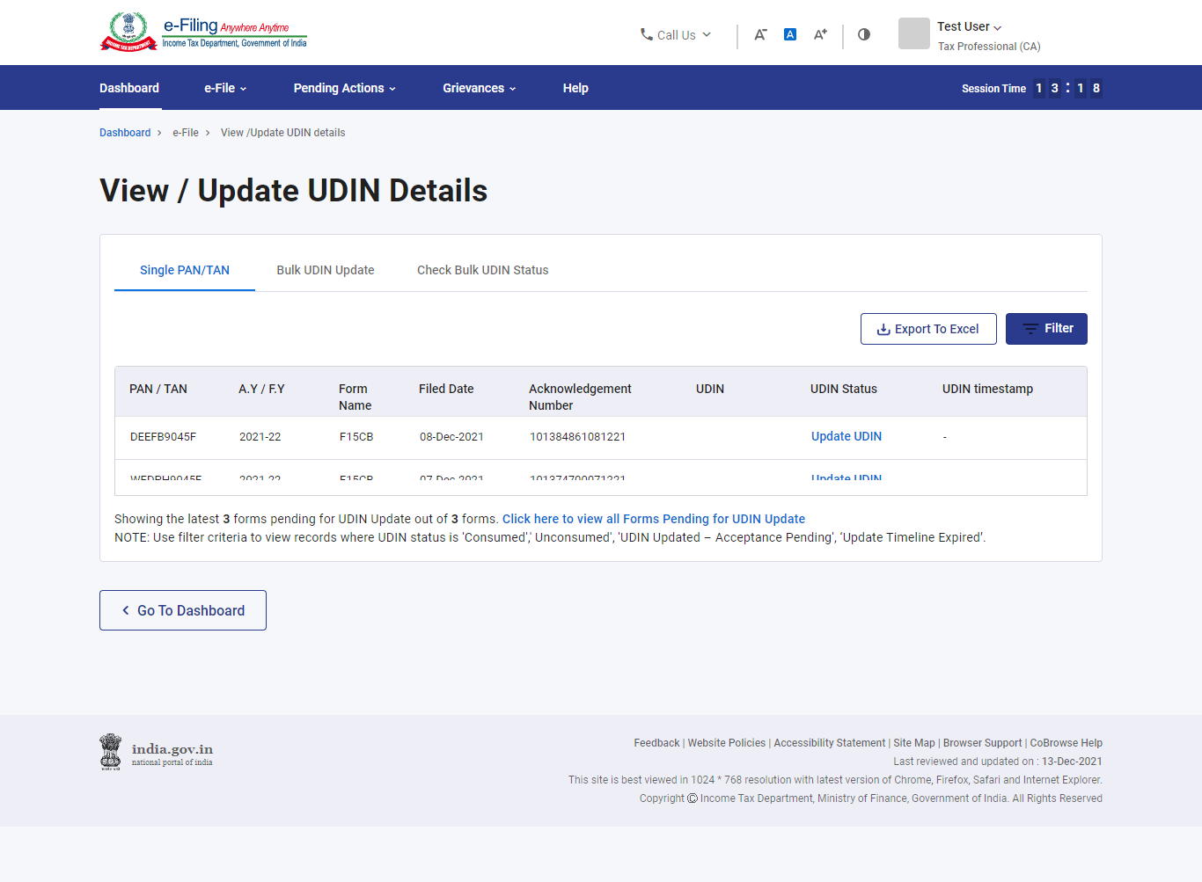

1. Click on **Bulk UDIN Update** tab

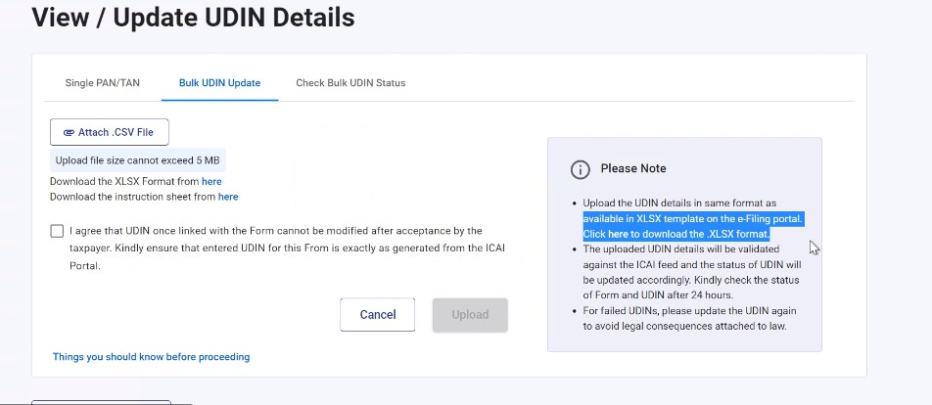

1. Download the XLSX Format

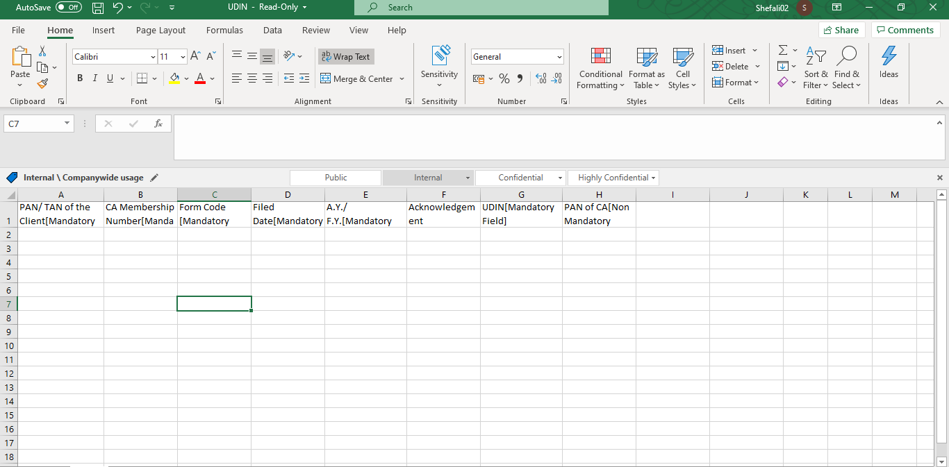

1. Check the date format in your Laptop/ desktop
2. Click on Date/ Time shown in the lower right corner of your laptop/ desktop’s screen

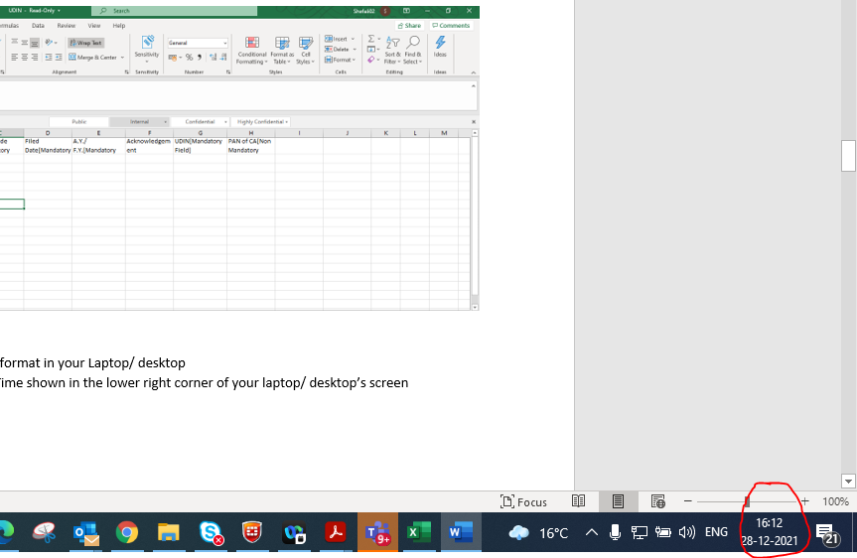

1. Click on the link – ‘Date and Time Settings’

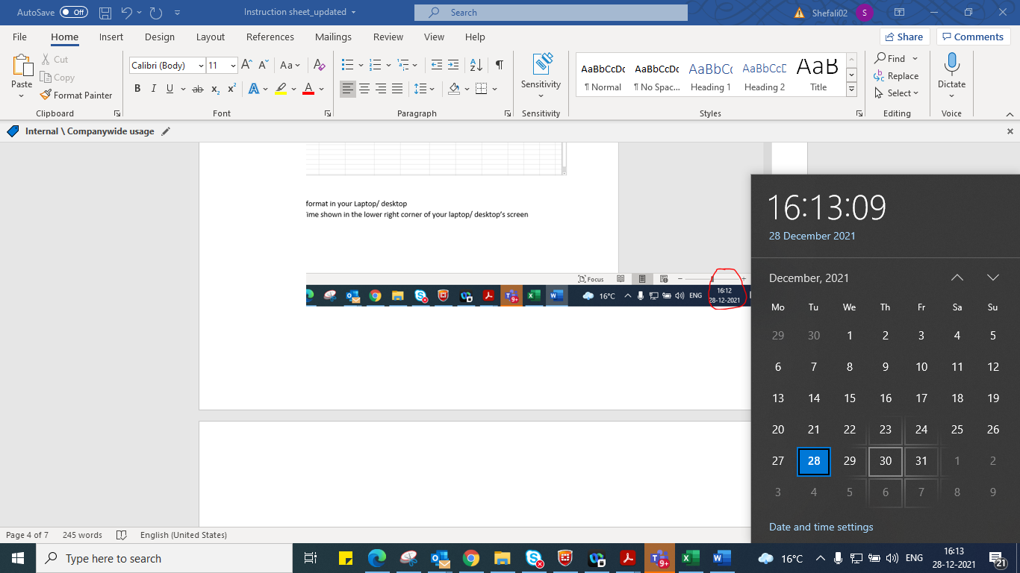

1. Click on the link ‘Date, time and regional formatting’

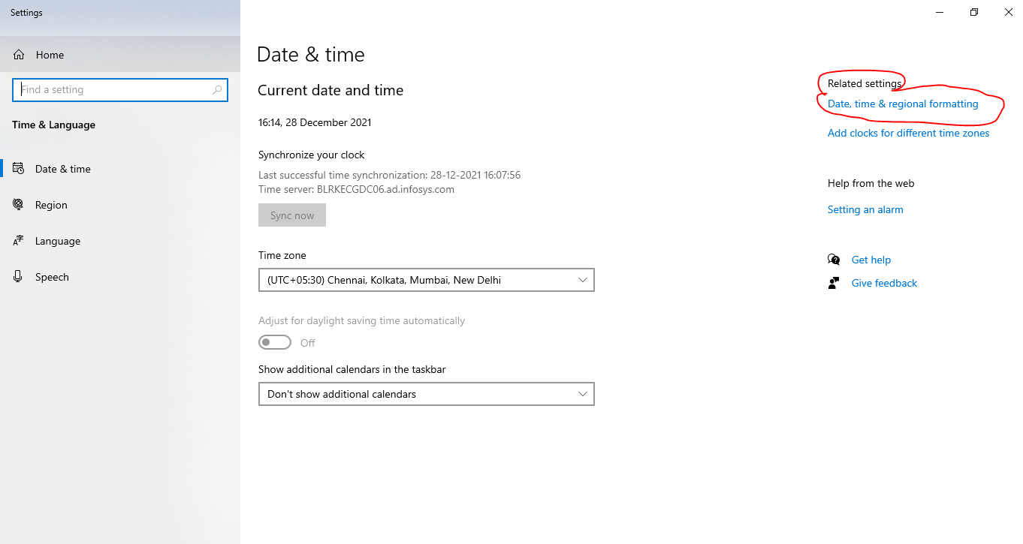

1. Select Country or region as **India.**

Then, go to the section ‘**Regional format data’** and check the format for **Short Date** and **Long Date**

If these formats are not same as shown in below picture, then click on **Change data formats** link**.**

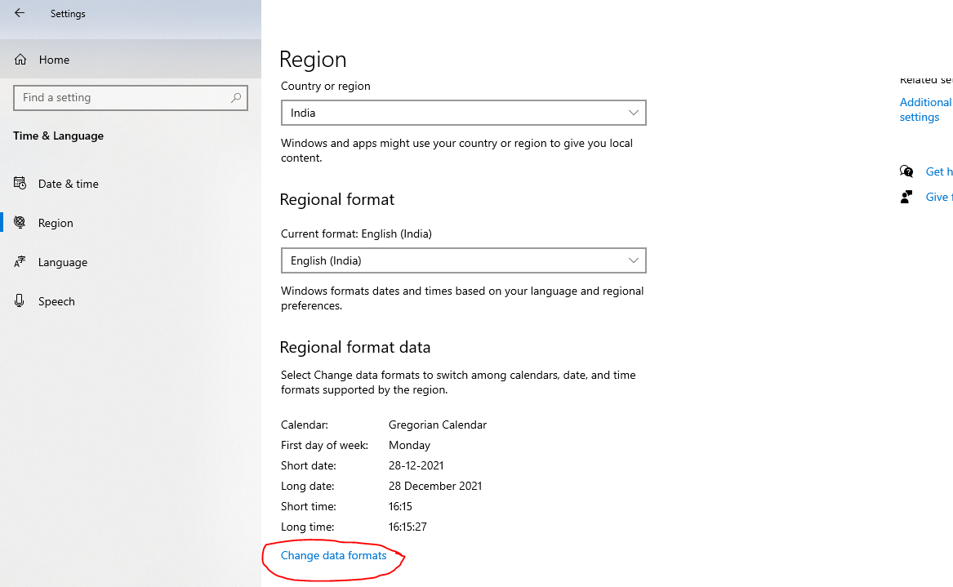

1. Change the short date format to DD-MM-YYYY, as shown below

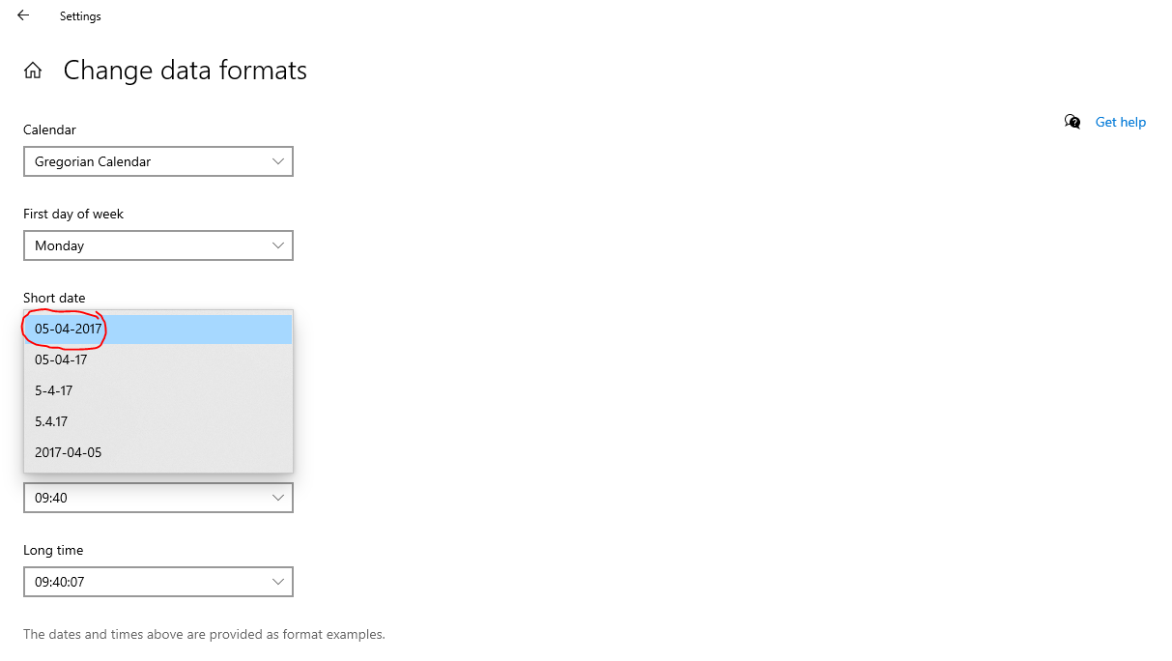

1. Select Long date format as DD-Month-YYYY, as shown below and then close the screen.

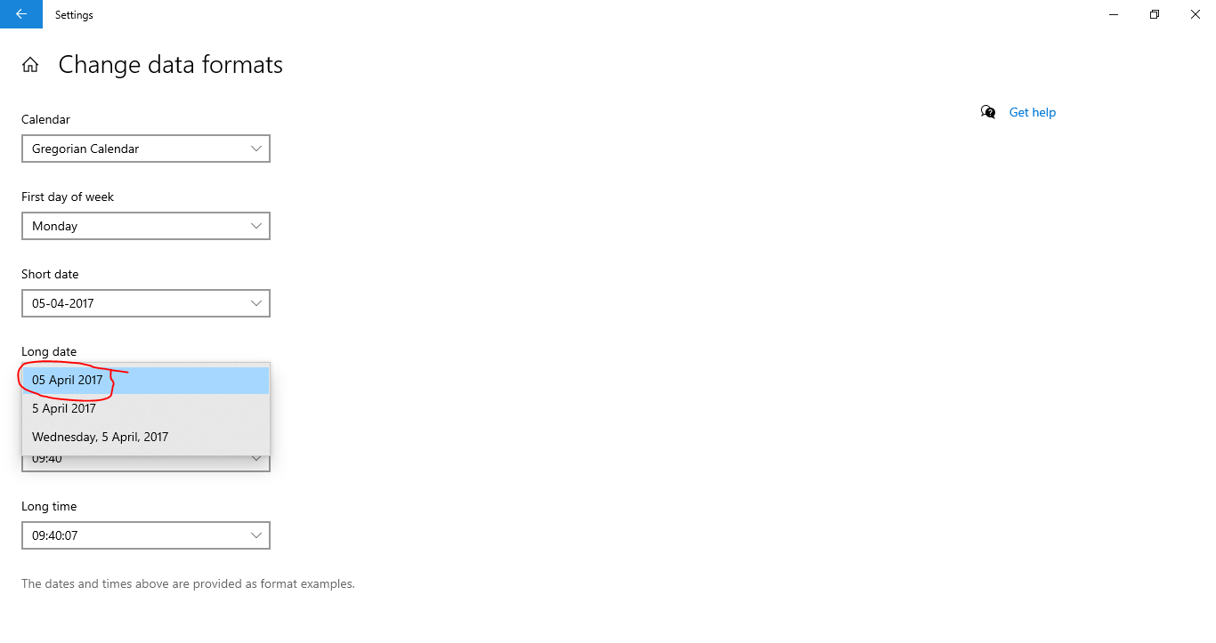

1. Open the XLSX template downloaded from the e-Filing Portal:



1. Following columns are mandatory to enter:

* PAN/TAN of the Client
* CA Membership Number
* Form Code
* Filed Date
* A.Y. / F.Y.
* Acknowledgement number
* UDIN

1. After opening the downloaded excel file, fill all the mandatory fields.

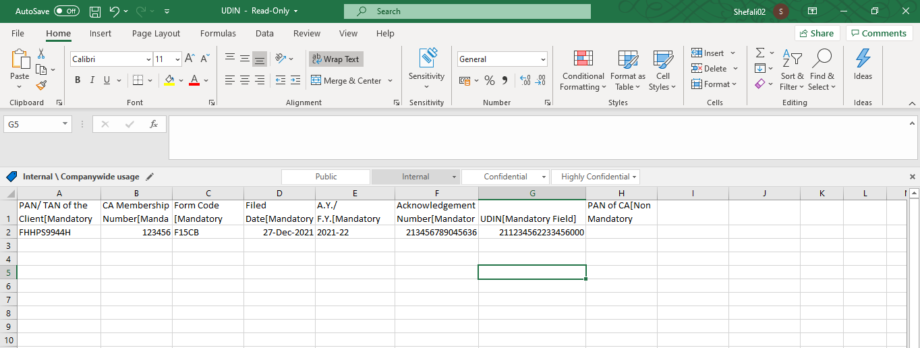

1. To fill the **Form Code**, refer the instruction sheet available on Bulk UDIN Update screen, under the link – ‘Things you should know before proceeding’.

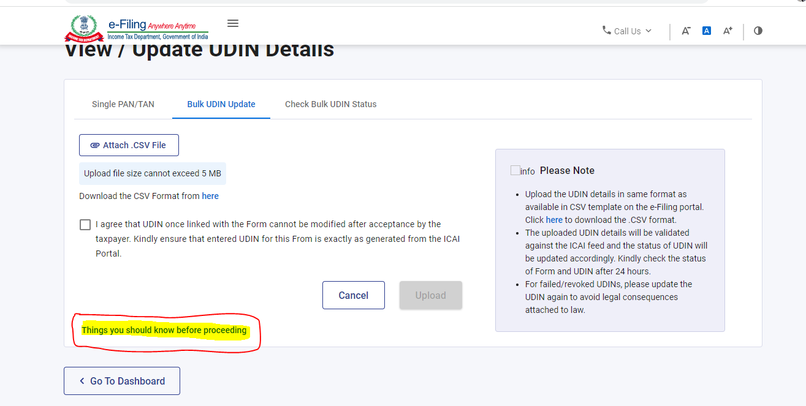

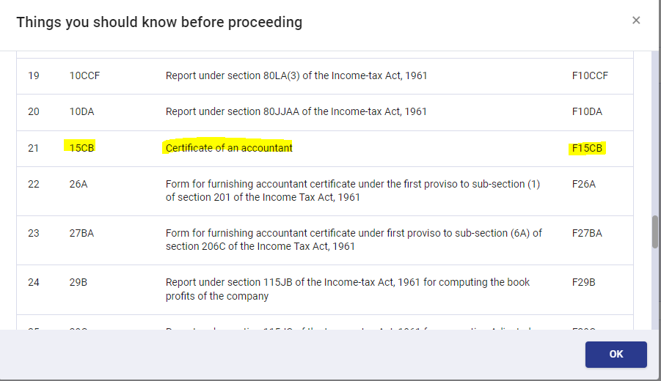

1. Click on **File** Option in the menu

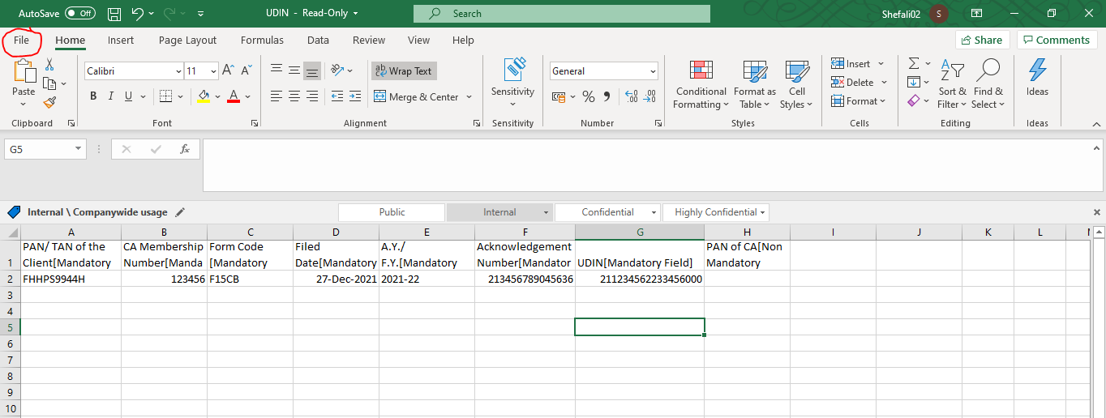

1. Click on **Save As** option, select **location** to save the file and select the format as **CSV (Comma delimited) (* .csv)**

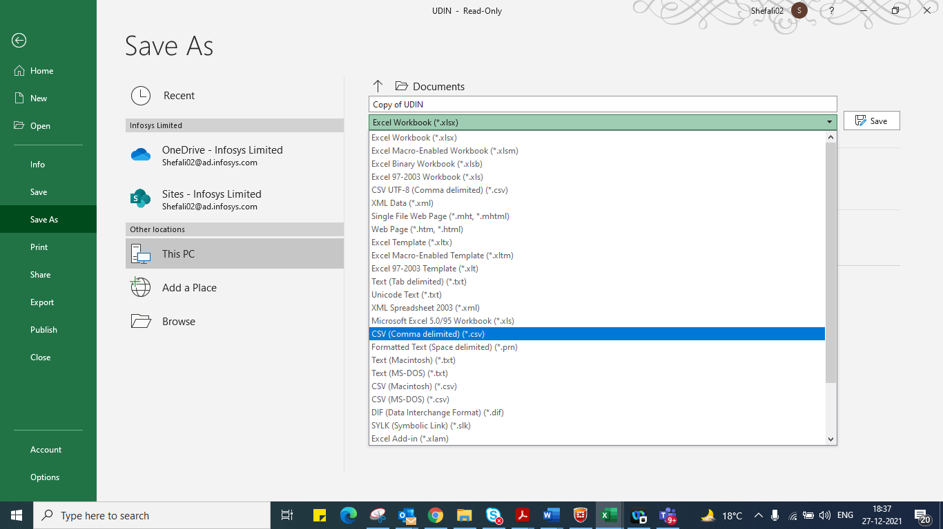

1. Click on **SAVE** button

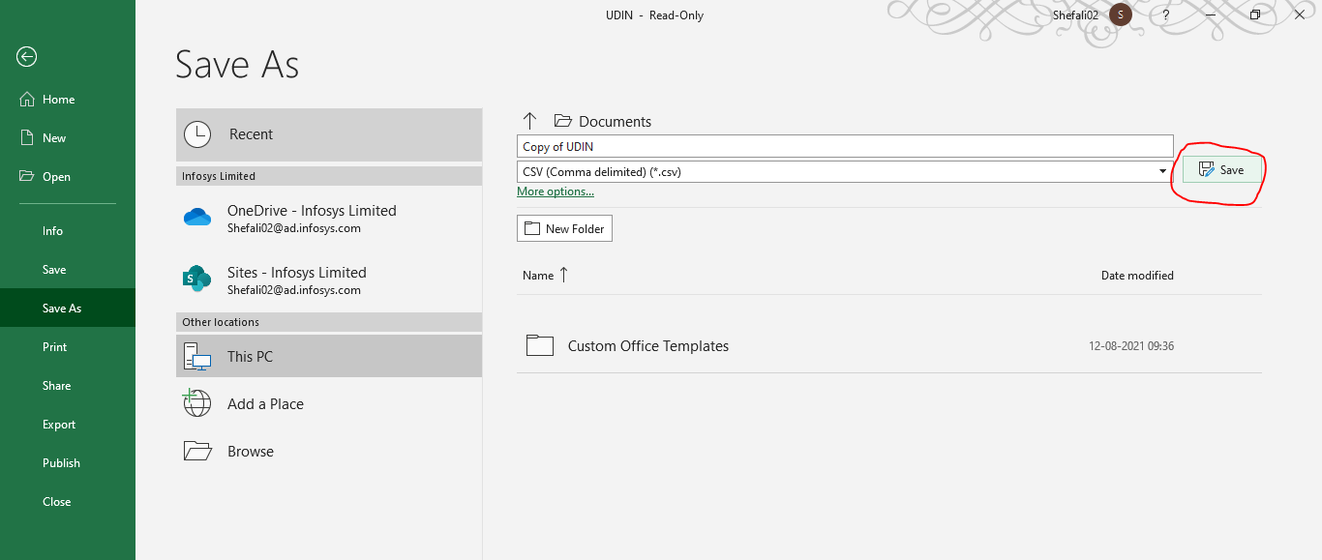

1. Go to Bulk UDIN Update screen on e-Filing Portal. (Follow steps 1 to 3)

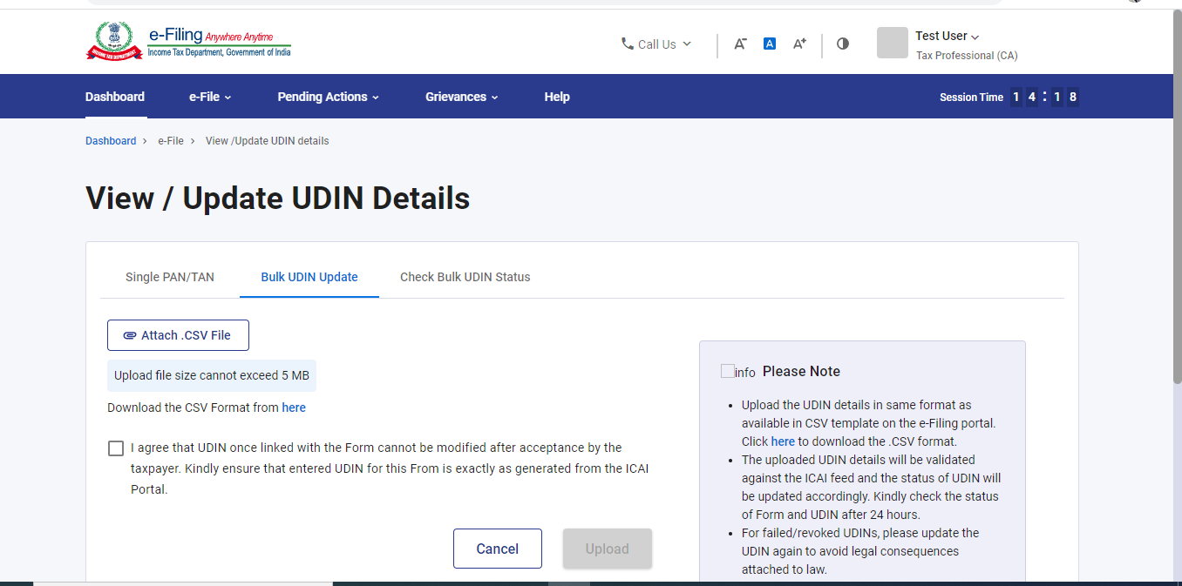

1. Upload the saved CSV file. Make sure that the file size does not exceed 5MB size and the file format is .CSV
2. Select the declaration and click on **Upload** button.
3. After the file is submitted successfully, you will get a token number. Save that Token number and check the status of file after 24 hours.